Catch-up to Get Ahead Communications Materials:
Sample Social Media for Parents and Providers
August 2021

Topic | Sample Post Copy | Suggested Image  Find additional graphics/sizes here.
COVID vaccine, other vaccines | #Vaccines protect you from serious infectious diseases. You can better protect yourself & your family from #COVID19, several kinds of cancer, flu, and other infectious diseases by getting caught up on your recommended vaccines. Learn more: https://www.hhs.gov/immunization/who-and-when/infants-to-teens/index.html #CatchUpGetAhead | 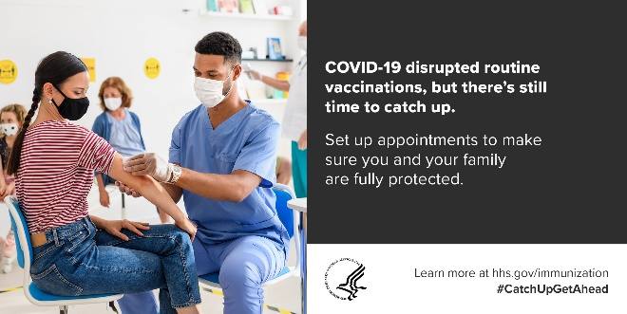
 | #Vaccines protect us from serious diseases, such as #COVID19, influenza, and measles. Make sure your family is caught up on all of their recommended vaccinations. Learn more: https://www.hhs.gov/immunization/who-and-when/infants-to-teens/index.html #CatchUpGetAhead | 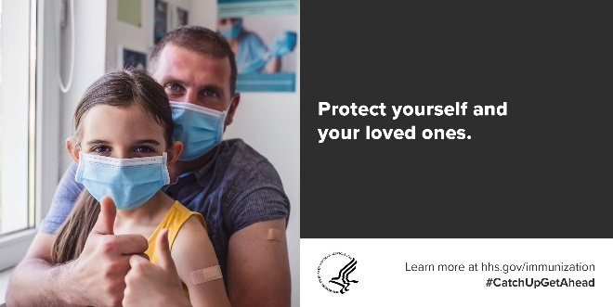
Role of providers in vaccination | Health Care Workers: Thank you for your work to vaccinate our communities! We still need your help in bringing your patients up to date on their #vaccinations. Learn more: https://www.hhs.gov/immunization/catch-up/index.html #CatchUpGetAhead | 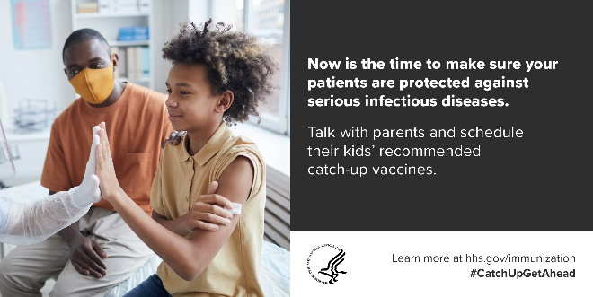
 | Now is the time to make sure all patients are caught up on their recommended vaccinations. Join us in communicating the importance of #vaccines. Learn how: https://www.hhs.gov/immunization/catch-up/index.html #CatchUpGetAhead | 